**Project Design Phase-II**

**Technology Stack (Architecture & Stack)**

|  |  |
| --- | --- |
| Date | 03 October 2022 |
| Team ID | PNT2022TMID51719 |
| Project Name | SmartFarmer –IoT Enabled Smart Farming Application. |
| Maximum Marks | 4 Marks |

**Technical Architecture :**

Technology architecture associates application components from application architecture with technology components representing software and hardware components. It provides a more concrete view of the way in which application components will be realized and deployed. It enables the migration problems that can arise between the different steps. It provides a more precise means of evaluating responses to constraints .

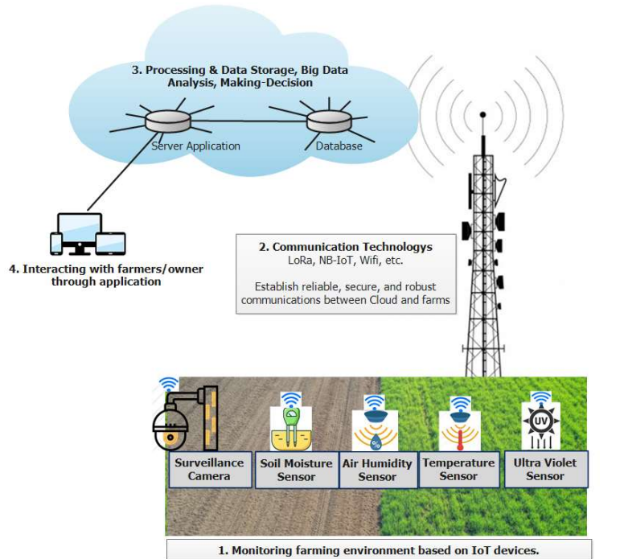

**Table-1 : Components & Technologies :**

|  |  |  |  |
| --- | --- | --- | --- |
| **S.No** | **Component** | **Description** | **Technology** |
| 1. | User Interface | The user interacts with application using Web UI. | HTML , CSS , JavaScript. |
| 2. | Computer-based application | Computer-based applications create precise farm plans, field & yield maps, crop scouting. | Java / Python . |
| 3. | **GPS Soil Sampling** | The data collected from sampling the soil is used to input the variable rate applications to optimize seeding and fertilizer input. | IBM AgroPad . |
| 4. | Smart Irrigation | IoT Sensor data is used to forecast water needs and control irrigation in real time , adjusting water level based on crop growth & local weather. | IBM Watson Assistant . |
| 5. | Cloud Database | The clean database is stored in IBM Cloud. | IBM Cloudant. |
| 6. | File Storage | Organize and store data on a hardware or on NAS device. | IBM Block Storage or Other Storage Service or Local Filesystem. |
| 7. | Prediction | These algorithm techniques are used to predict the proper way to make the stock in store. | IBM Weather API. |
| 8. | Infrastructure(cloud/server) | Setting hardware and software details for elements of a cloud environment to ensure that they can interoperate and communicate. | Local, Cloud Foundry, Kubernetes. |

**Table-2: Application Characteristics :**

| **S.No** | **Characteristics** | **Description** | **Technology** |
| --- | --- | --- | --- |
| 1. | Open-Source Frameworks | The open-source frameworks used are armOS, Tania, AgroSense, LiteFarm, ERPNext, Granular Insights. | IBM Cognos Analytics, Python. |
|  | Security Implementations | Request authentication using Encryptions. | Encryptions & Decryptions. |
|  | Scalable Architecture | Scalability consists of 3-tiers. | Web Server : HTML, CSS, JavaScript.  Application Server : Python.  Database Server : IBM Cloud. |
|  | Availability | The application is available for cloud users. | IBM Cloud Hosting. |
|  | Performance | The user can know how to maintain the inventory to increase profits. | ML algorithms. |